The Easter Experience
What is The Easter Experience?
The Easter Experience is an interactive re-telling of the Easter story for Year 5 pupils.
In this re-telling of the Easter story, children move around the auditorium watching events unfold at different locations.
They are given the opportunity to take part in waving palm leaves and are encouraged to become the crowd when Pontius Pilate asks the public to decide who should be crucified.
The Easter Experience is a moving and interactive drama with the actors answering questions in character at the end.
The Easter Experience explores why Easter is important to Christians. It links with a KS1 R.E. unit studied by many schools.
- The story of Holy Week and Easter is more complex and less familiar than the Christmas story. The Easter Experience brings it alive for both pupils and staff
- A narrator sets the scene and draws the audience in as spectators and participants
- The script, based closely on the Bible narratives, builds up the drama and tension
- Characters are explored and conflicts, political and personal, are exposed
- Questions are raised in the minds of the audience. At the end of the play, they are able to put their questions to the characters, as the actors – still in role – explain their motives and actions.
- The Easter Experience uses drama as a powerful educational tool to help pupils understand and think about the basis of the Christian faith.

“My son really enjoyed his afternoon, thank you… The children seemed to love it and asked great questions… The drama was mesmerising… The cast were fantastic and the children were really engaged… I thought we were coming to a talk but this was much better… I enjoyed seeing the Easter story rather than just reading it on paper… The actors were very engaging…”
Comments from parents, staff and children after the Easter Experience, March 2018

Make sure your Year 5’s don’t miss out this year!
Contact the SparkFish office by emailing bookings@sparkfish.org.uk or phone 01737 789100. We can then work with you to identify the best morning/afternoon session to suit your timetable. We may also be able to help if transport is a problem.

Bring the Easter story to life for your Year 5’s!
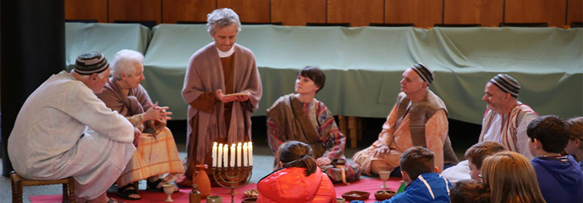

Easter Experience Booking Agreement
SparkFish are delighted to be able to offer The Easter Experience free of charge and we are so pleased that you would like to bring your Year 5’s this year. To ensure that we are able to run for many more years and maintain a great standard for all schools to enjoy, we have put together a booking agreement with some guidelines and information.
Please read through all of the information, sign at the bottom and return with your booking request to bookings@sparkfish.org.uk.
General Information:
- All SparkFish staff and volunteers are DBS checked
- Photography is permissible but please ensure that you only photograph children from your own school group.
- Squash is provided as a refreshment during the break, please ensure that any children who are allergic don’t participate.
- Please ensure you have read the attached risk assessment.

Transport:
- If you would like to attend and find that transport is an issue please do get in touch as SparkFish would hate for your school to miss out and is able to assist with transport. We can provide coaches or two minibuses depending on your school requirements.
- Minibuses are insured through the school we borrow them from and all our drivers are DVLA and DBS checked.
- Minibuses are provided free of charge, as they are borrowed and driven by volunteers.
- Coaches are hired, and we ask for a voluntary contribution towards the cost of coach hire, however there is no obligation to contribute.

Cancellation Costs:
- We are delighted to offer the Easter Experience free of charge to schools. However, a cancellation fee of £50 will be charged if bookings are cancelled after the 1st February. This is due to the impact on staff, volunteers, and other schools. With enough notice we are able to reallocate your Easter Experience time to another school.
- If coach hire is cancelled without adequate notice, the full coach hire fee may be charged.

I have read and agree to these terms on behalf of …………………………………………………………..…………………………
(Name of school)
Date: Signed:

Contact Phone Number: Email address:
SparkFish are a charitable trust supported by local churches and individuals. We do not charge for The Easter Experience but if you are able to make a voluntary contribution, it enables us to continue to provide the services we do and budget for staff.
For more information and to book The Easter Experience please email bookings@sparkfish.org.uk

▪

 

▪

▪


